Migrating EBS volumes from gp2 to gp3

Task 1: Sign in to AWS Management Console
- Click on the Open Console button, and you will get redirected to AWS Console in a new browser tab.
- On the AWS sign-in page,
  - Leave the Account ID as default. Never edit/remove the 12 digit Account ID present in the AWS Console. otherwise, you cannot proceed with the lab.
  - Now copy your User Name and Password in the Lab Console to the IAM Username and Password in AWS Console and click on the Sign in button.
- Once Signed In to the AWS Management Console, Make the default AWS Region as US East (N. Virginia) us-east-1.

Task 2: Launching an EC2 Instance
- Make sure you are in the US East (N. Virginia) us-east-1 Region.
- Navigate to EC2 by clicking on Services the menu in the top, then click on Ec2 in the Compute section.
- Navigate to Instances on the left panel and click on Launch Instances Button.
- Name : Enter MyEC2Server
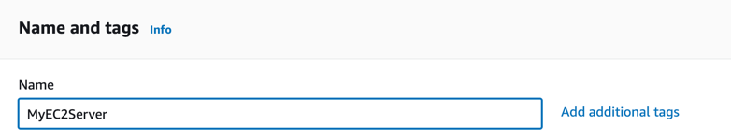
- For Amazon Machine Image (AMI): Search for Amazon Linux 2 AMI in the search box and click on the Select button.
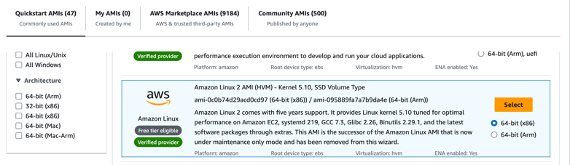
Note: if there are two AMI's present for Amazon Linux 2 AMI, choose any of them.
- For Instance Type: select t2.micro
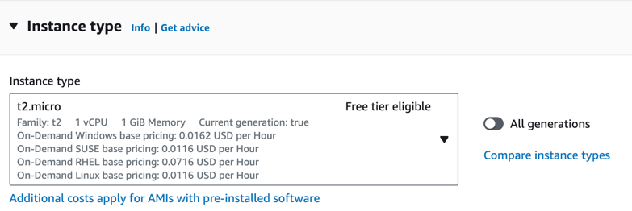
- For Key pair: Select Create a new key pair Button
  - Key pair name: WhizKey
  - Key pair type: RSA
  - Private key file format: .pem
- Select Create key pair Button.
- In Network Settings Click on Edit Button:
  - Auto-assign public IP: Enable
  - Select Create new Security group
  - Security group name : Enter MyEC2Server_SG
  - Description : Enter Security Group to allow traffic to EC2
- Keep Rest thing Default and Click on Launch Instance Button.
- Select View all Instances to View Instance you Created
- Launch Status: Your instance is now launching, Click on the instance ID and wait for complete initialization of the instance till status changes to Running.
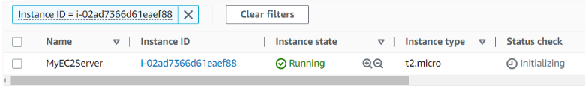
- Note down the Instance ID of the EC2 instance. A sample is shown in the screenshot below
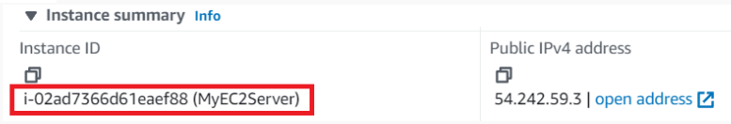

Task 3: Migrating the EBS Volumes from gp2 to gp3
- Make sure you are in the US East (N.Virginia) us-east-1 Region.
- Navigate to EC2 by clicking on the Services menu in the top, then click on the Volumes under Elastic Block Store section on the left navigation panel.
- In the Search Box, paste the Instance ID of your EC2 Instance.
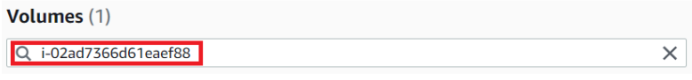
- Select the Volume associated with your EC2 Instance.
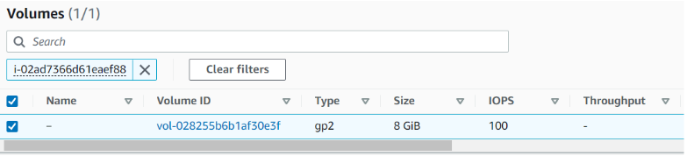
- After selecting Volume, expand the Actions button and click on Modify Volume.
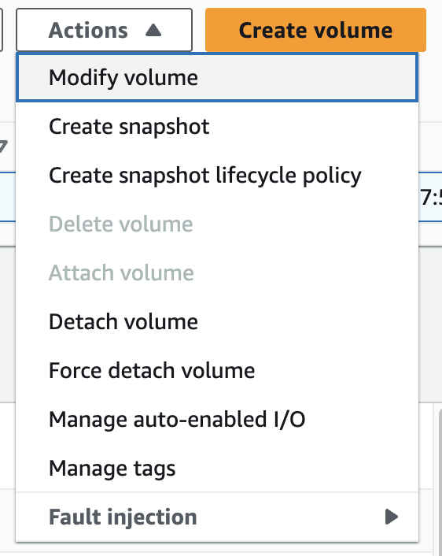
- In the Modify Volume, expand Volume type.
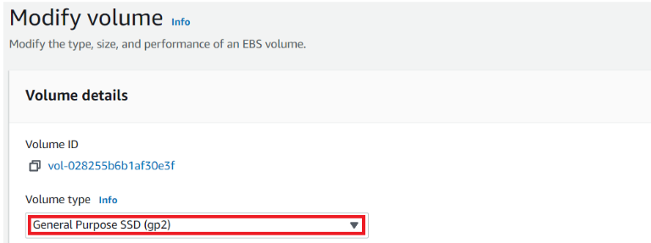
- Click on General Purpose SSD (gp3).
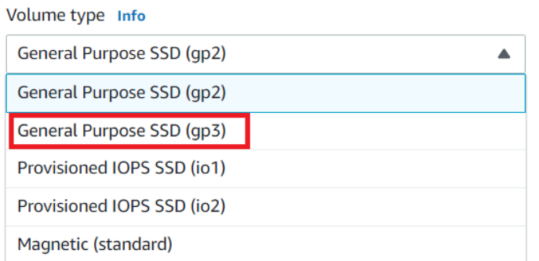
- Keep Rest thing Default and Click on Modify Button.
- You will get a prompt to Modify the Volume, Click on Modify Button.
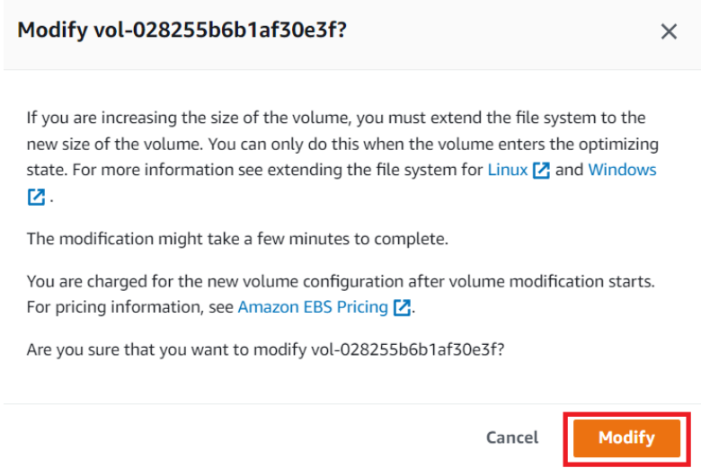
- It will take some time for the Volume to be modified.
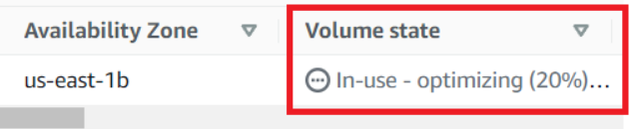
- After some time, the Volume State status will change to inuse and type will also be changed to gp3 from gp2.
